**REPORT**

|  |  |
| --- | --- |
| **Project ID:** | R - 107 |
| **Project:** | Hospital Readmissions as a Predictor of Mortality |
| **Investigator(s):** | Ashgar Ali, MD |
| **BCL Consultant(s):** | Spiro Stilianoudakis |
| **Date:** | 9/8/2018 |

**Introduction**

Readmission rates have long been used as a quality measure for hospitals. Broadly defined, a patient is considered to have been readmitted to a hospital if he or she was discharged, and then admitted to the same (or another) hospital within a specified time frame. Different time frames have been used to answer different research questions, with the most common being 30-day readmissions. It is of both clinical and fiscal importance for hospitals to maintain low readmission rates, along with low mortality rates. It is hypothesized that by reducing 30-day readmission rates, mortality rates may also be reduced. It is unclear how long after an initial discharge that a patient’s mortality can be attributed to their initial diagnosis. Therefore, we aim to see if 30-day readmission status is a predictor of mortality at various time points within a two year time-frame.

**Methods**

Patient data was retrospectively gathered through chart reviews from the Hunter Holmes McGuire VA Medical Center in Richmond, Virginia. The data contained 2353 unique patients that were admitted to the internal medicine service between the dates of March 1, 2009 and February 28, 2010. Each patient was followed for a maximum of 2 years. Time to death (days), 30-day readmission status, length of stay, patient diagnostic group, and severity index were recorded. Length of stay was defined as the number of days from index admission to discharge. Patients were categorized into one of 8 different diagnostic groups including cardiovascular, gastrointestinal, infections, metabolic, neurologic, renal, respiratory, and other. Patients were also grouped according to their Severity Index, which was categorized into five groups: <2.5, 2.5-5, 6-10, 11-30, and >30.

The patients were matched on diagnostic group and severity index using nearest neighbor propensity scores in a 2:1 ratio of non-readmission to readmission. In order to evaluate the matching, the two groups were compared using Student’s t-tests and Pearson Chi-Square tests for the continuous and categorical variables, respectively. A Kaplan-Meier curve was plotted against the two readmission groups and a stratified log-rank test was performed to evaluate the overall difference in the two curves in order to account for correlation induced by matching. Lastly, a stratified Cox proportional hazards model was performed and the hazard ratios, 95% confidence interval, and corresponding p-value was reported. All statistical analyses were conducted in R version 3.4.2 at a significance level of 0.05.

**Results**

Table 1 provides the patient summaries across the covariates before matching. The p-values after comparing between the non-readmissions group and the readmissions group are also presented. We see that there was a statistically significant relationship between readmission status and both diagnostic group and severity index. That is, the diagnostic group and severity index for patients in the unmatched sample were not independent of readmission status. Looking at the frequencies, we conclude that patients with cardiovascular related diseases and severity indexes less than 2.5 tended to be readmitted more often. However, for age, length of stay, ethnicity, gender, and race the two groups were not statistically different (p-values of 0.1529, 0.0721, 0.5718, 0.2051, and 0.6422 respectively), indicating that those variables were independent of readmission status.

**Table 1.** Summaries and the corresponding p-values before and after using nearest neighbor propensity score matching. The means and standard deviations of each of the two groups are provided for age and length of stay, while frequencies and proportions are provided for gender, race, ethnicity, diagnostic group, and severity index (n = 2387 for the unmatched sample; n = 735 for the matched sample).

|  |  |  |  |  |  |  |
| --- | --- | --- | --- | --- | --- | --- |
|  | **Unmatched Sample (n=2387)** | | | **Matched Sample (n=735)** | | |
| **Covariate** | **Readmitted** | **Not Readmitted** | **P-Value** | **Readmitted** | **Not Readmitted** | **P-Value** |
| Age (mean, sd) | 67.6 (12.2) | 66.4 (13.2) | 0.1529 | 67.6 (12.2) | 68.4 (13.4) | 0.4211 |
| Length_of_stay (mean, sd) | 4.5 (4.6) | 5.2 (8.7) | 0.0721 | 4.4 (4.6) | 4.5 (4.3) | 0.5928 |
| Diagnostic_group |  |  | 0.0019 |  |  | 0.9848 |
| Cardiovascular | 64 (26%) | 734 (34%) |  | 64 (26%) | 118 (24%) |  |
| Gastrointestinal | 34 (14%) | 236 (11%) |  | 34 (14%) | 76 (16%) |  |
| Infections | 31 (13%) | 206 (10%) |  | 31 (13%) | 64 (13%) |  |
| Metabolic | 22 (9%) | 157 (7%) |  | 22 (9%) | 54 (11%) |  |
| Neurological | 9 (4%) | 201 (9%) |  | 9 (4%) | 17 (3%) |  |
| Renal | 17 (7%) | 90 (4%) |  | 17 (7%) | 31 (6%) |  |
| Respiratory | 40 (16%) | 287 (13%) |  | 40 (16%) | 76 (16%) |  |
| Other | 29 (11%) | 231 (11%) |  | 29 (11%) | 54 (11%) |  |
| Ethnicity |  |  | 0.5718 |  |  | 0.7254 |
| Hispanic | 2 (1%) | 31 (2%) |  | 2 (1%) | 6 (2%) |  |
| Not Hispanic | 243 (99%) | 2111 (98%) |  | 243 (99%) | 484 (98%) |  |
| Gender |  |  | 0.2051 |  |  | 0.1663 |
| Female | 6 (3%) | 94 (4%) |  | 6 (3%) | 24 (3%) |  |
| Male | 239 (97%) | 2048 (96%) |  | 239 (97%) | 466 (97%) |  |
| Race |  |  | 0.6422 |  |  | 0.2573 |
| White | 129 (53%) | 1193 (56%) |  | 129 (53%) | 289 (59%) |  |
| Black | 113 (46%) | 923 (43%) |  | 113 (46%) | 196 (40%) |  |
| Other | 3 (1%) | 26 (1%) |  | 3 (1%) | 5 (1%) |  |
| Severity_index |  |  | <0.0001 |  |  | 0.205 |
| <2.5% | 127 (52%) | 1468 (69%) |  | 127 (52%) | 272 (56%) |  |
| 2.5 - 5% | 63 (26%) | 314 (15%) |  | 63 (26%) | 143 (29%) |  |
| 5 - 10% | 30 (12%) | 213 (10%) |  | 30 (12%) | 39 (8%) |  |
| 10 - 30% | 22 (9%) | 108 (5%) |  | 22 (9%) | 32 (7%) |  |
| >=30% | 3 (1%) | 39 (1%) |  | 3 (1%) | 4 (<1%) |  |

After matching, the sample size was reduced to include a total of 735 patients, 490 of which were not readmitted, while 245 were readmitted within 30 days. The same summaries and analyses are also provided for the matched sample in Table 1. We see that the two groups are more balanced across the covariates of interest. Furthermore, none of the p-values are statistically significant at the 0.05 level, leading to the conclusion that the sample is more balanced than before matching.

The median follow-up time for the matched sample was found to be 24 months. Kaplan-Meier curves separated by strata according to readmission status are provided in Figure 1. Patients that did not get readmitted within 30 days had higher probabilities of survival across the entire study. The stratified log-rank test for differences in the two curves provided evidence that the survival rate for patients that were readmitted within 30 days was significantly different than those that were not (p < 0.0001).

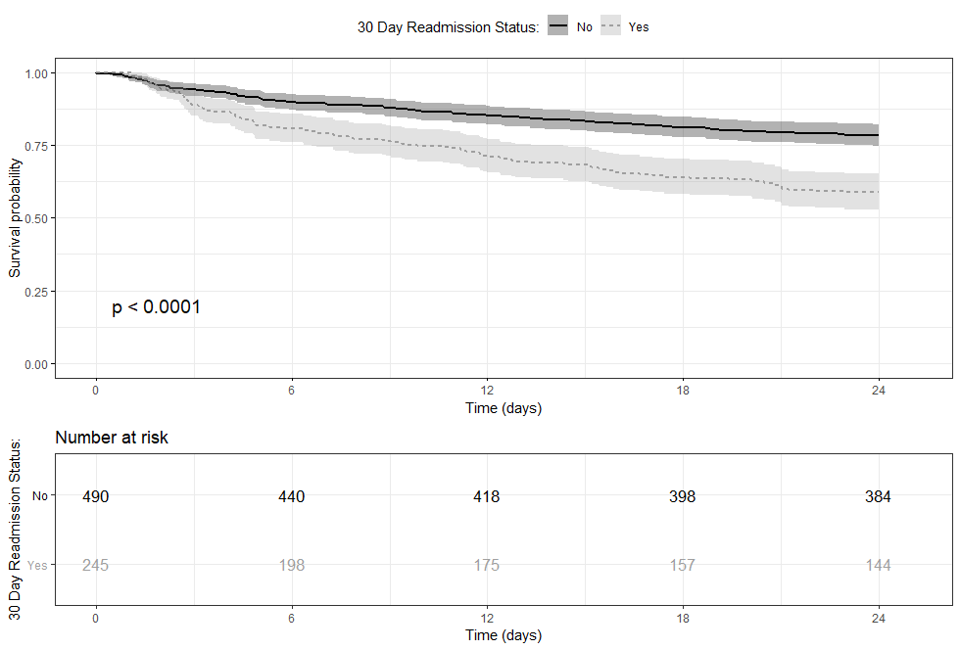

**Figure 1.** Kaplan-Meier curves separated by readmission status. The p-value of the stratified log-rank test was <0.0001 providing evidence of a difference in the rate of survival between the strata. Patients that were not readmitted within 30 days of discharge (solid line) were more likely to survive throughout the entire study period.

Of particular interest in this study were the survival times at 6, 12, 18, and 24 months respectively. Table 2 provides the estimated survival probabilities and 95% confidence intervals. The survival probabilities were consistently greater for patients that were not readmitted to the hospital within 30 days for all 4 time points. It was concluded that at 6, 12, 18, and 24 months patients that were not readmitted with 30 days of discharge had a greater probability of survival as compared to those that were readmitted. Table 3 provides the hazard ratios, confidence intervals and p-values for each parameter include in the Cox Proportional Hazards Model. The results of the model yielded a hazard ratio of 2.06 for patients that were readmitted within 30 days (95% CI of (1.550, 2.749); < 0.001). The hazard ratio indicates that the risk of death for patients that were readmitted to a hospital within 30 days of discharge was approximately 2 times that of patients that were not readmitted.

**Table 2.** The estimated survival probabilities for 6, 12, 18, and 24-month time points along with the 95% confidence intervals and p-values separated by readmission status. Patients that were not readmitted within 30 days were found to have a greater probability of survival for all 4 time points.

|  |  |  |  |  |  |  |  |
| --- | --- | --- | --- | --- | --- | --- | --- |
|  | **Readmission Status: No** | | | **Readmission Status: Yes** | | |  |
| **Time (Months)** | **Survival Probability** | **95% CI**  **Lower Upper** | | **Survival Probability** | **95% CI**  **Lower Upper** | | **P-Value** |
| 6 | 0.898 | 0.872 | 0.925 | 0.808 | 0.76 | 0.859 | <0.001 |
| 12 | 0.853 | 0.822 | 0.885 | 0.71 | 0.656 | 0.769 | <0.001 |
| 18 | 0.812 | 0.778 | 0.848 | 0.641 | 0.583 | 0.704 | <0.001 |
| 24 | 0.784 | 0.748 | 0.821 | 0.588 | 0.529 | 0.653 | <0.001 |

**Table 3.** Hazard ratios, 95% confidence intervals, and p-values for variables included in the Cox Proportional Hazards Model.

|  |  |  |  |  |
| --- | --- | --- | --- | --- |
|  |  | **95% Confidence Interval** | |  |
| **Variable** | **Hazard Ratio** | **Lower** | **Upper** | **P-Value** |
| 30 Day Readmission (Yes) | 2.06 | 1.55 | 2.749 | <0.001 |
| Age | 1.02 | 1.003 | 1.029 | 0.017 |
| Gender: Male | 0.988 | 0.456 | 2.139 | 0.976 |
| Race: |  |  |  |  |
| Black | 0.91 | 0.681 | 1.217 | 0.526 |
| Other | 1.418 | 0.344 | 5.836 | 0.629 |
| Ethnicity: Not Hispanic | 2.895 | 0.403 | 20.788 | 0.291 |
| log(Length of Stay) | 1.254 | 0.981 | 1.604 | 0.071 |
| Diagnostic Group: |  |  |  |  |
| Gastrointestinal | 1.202 | 0.757 | 1.908 | 0.436 |
| Infections | 0.657 | 0.37 | 1.166 | 0.151 |
| Metabolic | 1.086 | 0.628 | 1.879 | 0.767 |
| Neurological | 1.341 | 0.687 | 2.616 | 0.39 |
| Other | 1.651 | 1.051 | 2.593 | 0.03 |
| Renal | 0.533 | 0.25 | 1.134 | 0.102 |
| Respiratory | 1.159 | 0.757 | 1.773 | 0.498 |
| Severity Index: |  |  |  |  |
| 2.5 - 5% | 1.531 | 1.048 | 2.236 | 0.028 |
| 5 - 10% | 3.46 | 2.27 | 5.274 | <0.001 |
| 10 - 30% | 4.541 | 2.857 | 7.218 | <0.001 |
| >=30% | 18.237 | 7.647 | 43.492 | <0.001 |